The 5 RIRs and Their Regions:
# Source: AI Source: Provided by: [Data Path: Persons Table -> ID Column: 1, Name_En Column: Motasem Essam] -> From: [ChatGPT] on [1/16/2026]
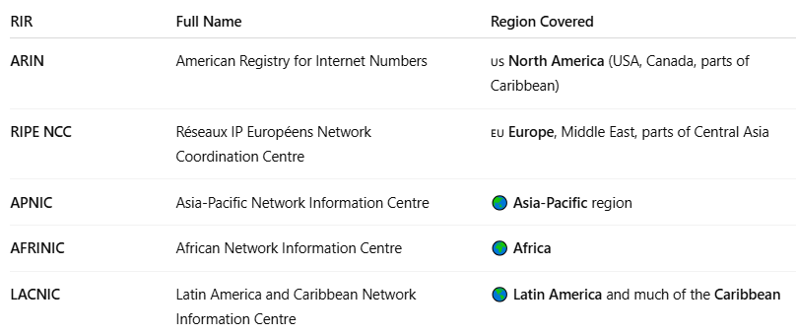

RIR | Full Name | Region Covered
ARIN | American Registry for Internet Numbers | 🇺🇸 North America (USA, Canada, parts of Caribbean)
RIPE NCC | Réseaux IP Européens Network Coordination Centre | 🇪🇺 Europe, Middle East, parts of Central Asia
APNIC | Asia-Pacific Network Information Centre | 🌏 Asia-Pacific region
AFRINIC | African Network Information Centre | 🌍 Africa
LACNIC | Latin America and Caribbean Network Information Centre | 🌎 Latin America and much of the Caribbean

